How to Make a Proceedings Paper Submission

Autorka Autorović (autor@autor.aut)

Laboratory for Experimental Psychology, University of Belgrade

[INSERT ORCID HERE]

Autor Autorovski (autor@autor.aut)

Institute of Psychology, University of Belgrade

[INSERT ORCID HERE]

Abstract
The abstract should be one paragraph, indented 1/8 inch on both sides, in 9 point font with single spacing. The heading “Abstract” should be 10 point, bold, centered, with one line of space below it. This one-paragraph abstract section is required only for standard six page proceedings papers. Following the abstract should be a blank line, followed by the header “Keywords:” and a list of descriptive keywords separated by semicolons, all in 9 point font, as shown below.
Keywords: add your choice of indexing terms or keywords; kindly use a semicolon; between each term

General Instructions
Conference proceedings will be available online on this link. Authors that wish to submit proceedings should apply via the questionnaire that will be published on the website, conference Facebook page and will be sent via e-mail to the authors. Please submit your papers by the date in the notice of application for proceedings. Papers are submitted by sending them to the email eip@f.bg.ac.rs, with the subject created following this pattern: “proceedings_submission_[first_author_surname]”
Paper length should be between 6000 and 8000 characters with spaces (excluding abstract, title, authors’ names, affiliations and keywords). Papers should be written in English.
Please use Microsoft Word text processor, please download template for EIP proceedings. Papers that do not follow the template, will not be sent for a review.
Paper should contain the following (in accordance with the APA7 standards):
- Short abstract (from 1000 to 1400 characters with spacing) – abstract for the conference proceedings should not be the same as the one submitted for the conference. In addition, it should not contain statistics. Unless statistical technique is a topic of the paper, used statistical techniques should not be mentioned in the abstract.
- Up to 5 keywords
- Short introduction and clearly stated problem and the aim of the study
- Method
- Results
- Discussion and conclusions
- Reference list
When displaying statistics, it is necessary to clearly display values, degrees of freedom, and level of significance (e.g., t(121) = 15.34, p<.05).
Tables should be prepared in Word or another editable format. Tables and figures should be copied from statistics software and prepared for Word and adjust for the current paper (figures should be high-resolution, at least 300 dpi). The same data should not be displayed in both text and in tables/figures. Each table, figure, and/or picture should be numbered and with adequate title placed above the table, figure, or picture. Authors should refer to each table, graph or picture in the text.
Paper should be written according to APA7 standards. You can download instructions for formating statistical parameters.

Additional Guidelines for Writing Papers Based on Qualitative Methodology
In accordance with the APA reporting standards from 2018 (Levitt et al., 2018), when writing scientific papers using qualitative methodology, it is particularly important to consider the following elements:

Contextualization, Clarity, and Thoroughness It is important to describe the context of research, phenomenon and the participants (location, time, social dynamics).
The research paradigm and approach (e.g., interpretative, critical, feminist, phenomenological, socio-constructivist) should be explicitly stated and justified, along with the choice of the overall research design.
Qualitative research does not rely on variables or hypotheses. However, it is important to clearly outline the research topic, aims, research questions, and even motivation for the study.
Basic characteristics of participants, documents, or analyzed events, as well as the ways and reasons for selecting (or excluding) specific participants, documents, events, or any other materials, should be provided.
Authors should define the type of analysis (e.g., thematic, interpretative phenomenological, case study, narrative, discursive), units of analysis (e.g., sentence, document, photograph), and approach to data analysis (deductive, inductive, combined).
The presentation of results should go beyond mere description or paraphrasing of participants’ words and include a deeper interpretation of data, attempting abstraction and generalization.
Quantification (e.g., number of coded segments within a specific theme) and/or schematization (e.g., thematic maps) of individual data may be used to improve the clarity of results and summarize them (given the limitations in the number of characters), but are not required.
If applicable, it is desirable to describe the theoretical and practical contributions and implications of the research.

Credibility Transparency and detail in describing methods are crucial. Authors should justify decisions made during data collection or analysis.
If the method allows, presenting participants’ statements or excerpts from documents/materials that vividly illustrate the analyzed phenomenon is recommended.
Authors should explain how they sought to ensure the credibility of the research (e.g., triangulation, coding with a colleague, calculating inter-coder agreement, member check) and clearly indicate the limitations of the study, recommendations for further research, and any ethical issues/dilemmas.

Terminology and Writing Style Combining results with discussion in a single section (often labeled as Findings instead of Results) is acceptable.
Different terminology may be used in the methodology section compared to quantitative research, referring to participants instead of sample or data generation/ data collection strategies instead of research instruments.
Writing in the first person singular is acceptable, and authors should clearly position themselves in relation to the research topic and context, reflecting on how the researcher’s position influenced the research process and interpretation of results.

Mixed methods When presenting mixed methods research, it is necessary to justify the choice of this method and describe how the data complement each other. Ensuring coherence regarding the research approach, analysis, and interpretation of results is particularly important in mixed methods research. Third Level Headings Third level headings should be 10-point, initial caps, bold, and flush left. Leave one line space above the heading, but no space after the heading.

General Formatting Instructions
The entire content of a paper (including figures, references, and anything else) can be no longer than six pages.
The text of the paper should be formatted in two columns with an overall width of 17.8 cm and length of 23.5 cm, with 0.25 inches between the columns. Leave two-line spaces between the last author listed and the text of the paper. The left margin should be 0.75 inches, and the top margin should be 1 inch. Use A4 paper. Use 10-point Times Roman with 12 point vertical spacing, unless otherwise specified.
The title should be 14 points, bold, and centered. The title should be formatted with initial caps (the first letter of content words capitalized and the rest lower case). Each author’s name should appear on a separate line, 11 point bold, and centered, with the author’s email address in parentheses. Under each author’s name list the author’s affiliation in ordinary 10-point type.
Indent the first line of each paragraph by 1/8 inch (except for the first paragraph of a new section). Do not add extra vertical space between paragraphs.

First Level Headings
First level headings should be 12-point, initial caps, bold and centered. Leave one line space above the heading and 1/4-line space below the heading.

Second Level Headings
Second level headings should be 11-point, initial caps, bold, and flush left. Leave one line space above the heading and 1/4-line space below the heading.

Third Level Headings Third level headings should be 10-point, initial caps, bold, and flush left. Leave one line space above the heading, but no space after the heading.

Formalities, Footnotes, and Floats
Use standard APA citation format (APA7). Citations within the text should include the authors’ last names and year. If the authors' names are included in the sentence, place only the year in parentheses, as in Newell and Simon (1972), but otherwise place the entire reference in parentheses with the authors and year separated by a comma (Newell & Simon, 1972). List multiple references alphabetically and separate by semicolons (Chalnick & Billman, 1988; Newell & Simon, 1972). Use the “et al.” for three or more authors. Each in-text reference must be present in full reference list at the end of the paper.

Footnotes
Indicate footnotes with a number in the text. Place them in 9-point type at the bottom of the column on which they appear. Precede the footnote with a horizontal rule.

Tables
Number tables consecutively. Place the table number and title (in 10 point) above the table with one line space above the caption and one line space below it, as in Table 1. You may float tables to the top or bottom of a column or set wide tables across both columns. Do not insert image of the table as a replacement.

Table 1: Sample table title.

Error type | Example
Take smaller | 63 - 44 = 21
Always borrow | 96 - 42 = 34
0 - N = N | 70 - 47 = 37
0 - N = 0 | 70 - 47 = 30

Figures
All figures must be dark and legible for purposes of reproduction and should not be hand drawn. Number figures sequentially, placing the figure number and caption, in 10 points, after the figure with one line space above the caption and one line space above it, as in Figure 1. If necessary, leave extra white space at the bottom of the page to avoid splitting the figure and figure caption. You may float figures to the top or bottom of a column or set figures across both columns.

Figure 1: This is a figure.
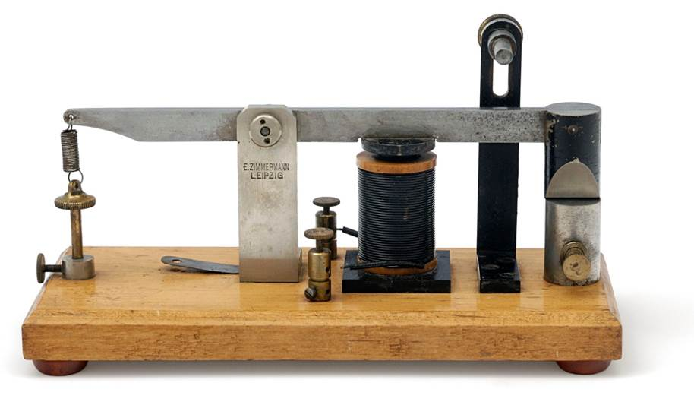
All figures must be high quality (300 dpi). When resized to the desired size, the letters cannot be smaller than 10-points. You may float figures to the top or bottom of a column or set wide tables across both columns.

Acknowledgments
Place acknowledgments (including funding information) in a section at the end of the paper.

References Instructions
Follow the APA7 Publication Manual for citation format, both within the text and in the reference list, with the following exceptions: (a) do not cite the page numbers of any book, including chapters in edited volumes; (b) use the same format for unpublished references as for published ones. Alphabetize references by the surnames of the authors, with single author entries preceding multiple author entries. Order references by the same authors by the year of publication, with the earliest first.
Use the first level section heading, “References”, as shown below. Use a hanging indent style, with the first line of the reference flush against the left margin and subsequent lines indented by 1/8 inch. Below are example references for a conference paper, book chapter, journal article, dissertation, book, technical report, and edited volume, respectively.

References
Chalnick, A., & Billman, D. (1988). Unsupervised learning of correlational structure. Proceedings of the tenth annual conference of the cognitive science society (pp. 510-516). Hillsdale, NJ: Lawrence Erlbaum Associates.
Feigenbaum, E. A. (1963). The simulation of verbal learning behavior. In E. A. Feigenbaum & J. Feldman (Eds.), Computers and thought. New York: McGraw-Hill.
Hill, J. A. C. (1983). A computational model of language acquisition in the two-year old. Cognition and Brain Theory, 6, 287-317.
Matlock, T. (2001). How real is fictive motion? Doctoral dissertation, Psychology Department, University of California, Santa Cruz.
Newell, A., & Simon, H. A. (1972). Human problem solving. Englewood Cliffs, NJ: Prentice-Hall.
Ohlsson, S., & Langley, P. (1985). Identifying solution paths in cognitive diagnosis (Tech. Rep. CMU-RI-TR-85-2). Pittsburgh, PA: Carnegie Mellon University, The Robotics Institute.
Shrager, J., & Langley, P. (Eds.) (1990). Computational models of scientific discovery and theory formation. San Mateo, CA: Morgan Kaufmann.

Sample of the first footnote.
Sample of the second footnote.

