How to Make a Proceedings Paper Submission

Autorka Autorović (autor@autor.aut)

Laboratory for Experimental Psychology, University of Belgrade

Autor Autorovski (autor@autor.aut)

Institute of Psychology, University of Belgrade

Abstract
The abstract should be one paragraph, indented 1/8 inch on both sides, in 9 point font with single spacing. The heading “Abstract” should be 10 point, bold, centered, with one line of space below it. This one-paragraph abstract section is required only for standard six page proceedings papers. Following the abstract should be a blank line, followed by the header “Keywords:” and a list of descriptive keywords separated by semicolons, all in 9 point font, as shown below.
Keywords:add your choice of indexing terms or keywords; kindly use a semicolon; between each term

General Formatting Instructions
The entire content of a paper (including figures, references, and anything else) can be no longer than six pages.
The text of the paper should be formatted in two columns with an overall width of 17.8 cm and length of 23.5 cm, with 0.25 inches between the columns. Leave two line spaces between the last author listed and the text of the paper. The left margin should be 0.75 inches, and the top margin should be 1 inch. Use A4 paper. Use 10 point Times Roman with 12 point vertical spacing, unless otherwise specified.
The title should be 14 point, bold, and centered. The title should be formatted with initial caps (the first letter of content words capitalized and the rest lower case). Each author’s name should appear on a separate line, 11 point bold, and centered, with the author’s email address in parentheses. Under each author’s name list the author’s affiliation in ordinary 10 point type.
Indent the first line of each paragraph by 1/8 inch (except for the first paragraph of a new section). Do not add extra vertical space between paragraphs.

First Level Headings
First level headings should be 12 point, initial caps, bold and centered. Leave one line space above the heading and 1/4 line space below the heading.

Second Level Headings
Second level headings should be 11 point, initial caps, bold, and flush left. Leave one line space above the heading and 1/4 line space below the heading.

Third Level Headings Third level headings should be 10 point, initial caps, bold, and flush left. Leave one line space above the heading, but no space after the heading.

Formalities, Footnotes, and Floats
Use standard APA citation format (APA6). Citations within the text should include the author's last name and year. If the authors' names are included in the sentence, place only the year in parentheses, as in Newell and Simon (1972), but otherwise place the entire reference in parentheses with the authors and year separated by a comma (Newell & Simon, 1972). List multiple references alphabetically and separate them by semicolons (Chalnick & Billman, 1988; Newell & Simon, 1972). Use the “et al.” construction only after listing all the authors to a publication in an earlier reference and for citations with four or more authors.

Footnotes
Indicate footnotes with a number in the text. Place them in 9 point type at the bottom of the column on which they appear. Precede the footnote with a horizontal rule.

Tables
Number tables consecutively. Place the table number and title (in 10 point) above the table with one line space above the caption and one line space below it, as in Table 1. You may float tables to the top or bottom of a column, or set wide tables across both columns.

Table 1: Sample table title.

Error type | Example
Take smaller | 63 - 44 = 21
Always borrow | 96 - 42 = 34
0 - N = N | 70 - 47 = 37
0 - N = 0 | 70 - 47 = 30

Figures
All artwork must be very dark for purposes of reproduction and should not be hand drawn. Number figures sequentially, placing the figure number and caption, in 10 point, after the figure with one line space above the caption and one line space below it, as in Figure 1. If necessary, leave extra white space at the bottom of the page to avoid splitting the figure and figure caption. You may float figures to the top or bottom of a column, or set figures across both columns.
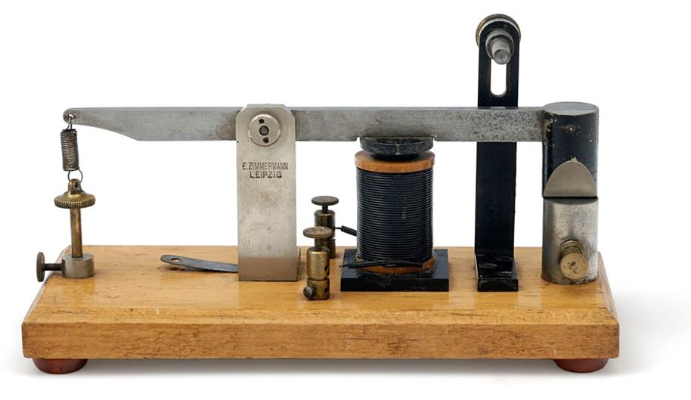
Figure 1: This is a figure.

Acknowledgments
Place acknowledgments (including funding information) in a section at the end of the paper.

References Instructions
Follow the APA 7 Publication Manual for citation format, both within the text and in the reference list. Alphabetize references by the surnames of the authors, with single author entries preceding multiple author entries. Order references by the same authors by the year of publication, with the earliest first.
Use a first level section heading, “References”, as shown below. Use a hanging indent style, with the first line of the reference flush against the left margin and subsequent lines indented by 1/8 inch. Below are example references for a conference paper, book chapter, journal article, dissertation, book, and technical report.

References
Bland, A. (2017, November). The implementation of a junior Samoan language programme in a South Island, New Zealand secondary school context [Paper presentation]. Australian Association for Research in Education (AARE) Conference 2017, Canberra, Australia. https://bit.ly/37DvrHR
Cismas, S. C. (2010). Educating academic writing skills in engineering. In P. Dondon & O. Martin (Eds.), Latest trends on engineering education (pp. 225-247). WSEAS Press.
Le Couteur, D., Kendig, H., Naganathan, V., & McLachlan, A. (2010). The ethics of prescribing medications to older people. In S. Koch, F. M. Gloth, & R. Nay (Eds.), Medication management in older adults (pp. 29-42). Springer. https://doi.org/10.1007/978-1-60327-457-9_3
Hudd, S.S., Sardi, L.M., & Lopriore, M.T. (2013). Sociologists as writing instructors: Teaching students to think, teaching an emerging skill, or both? Teaching Sociology, 40, 32-45. https:doi.org/10.1177/0092055X12458049
Leigh, J. (2010). Self-determined mindfulness and attachment style in college students (Publication No. 305210119) [Doctoral dissertation, Indiana State University]. ProQuest Dissertations and Theses Global.
Moran, A., & Toner, J. (2017). A critical introduction to sport psychology (3rd ed.). Routledge.
Federal Interagency Forum on Child and Family Statistics. (2013). America’s children: key national indicators of well-being. http://childstats.gov/americaschildren/index2.asp.

Sample of the first footnote.
Sample of the second footnote.

